**Quick Sort and Merge sort**

**Quick Sort**

Quick Sort is a Divide and Conquer algorithm. It picks an element as pivot and partitions the given array around the picked pivot. There are many different versions of quickSort that pick pivot in different ways.

1. Always pick first element as pivot.
2. Always pick last element as pivot (implemented below)
3. Pick a random element as pivot.
4. Pick median as pivot.

The key process in quickSort is partition(). Target of partitions is, given an array and an element x of array as pivot, put x at its correct position in sorted array and put all smaller elements (smaller than x) before x, and put all greater elements (greater than x) after x. All this should be done in linear time.

**Pseudo Code for recursive QuickSort function :**

/\* low --> Starting index, high --> Ending index \*/

quickSort(arr[], low, high)

{

if (low < high)

{

/\* pi is partitioning index, arr[pi] is now

at right place \*/

pi = partition(arr, low, high);

quickSort(arr, low, pi - 1); // Before pi

quickSort(arr, pi + 1, high); // After pi

}

}

[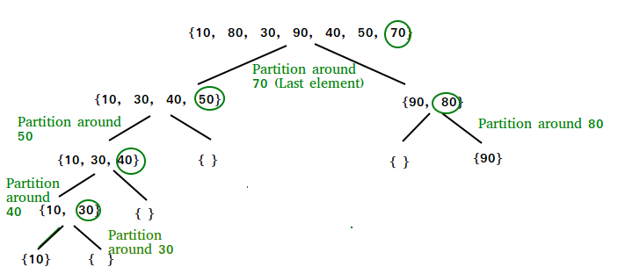](https://www.geeksforgeeks.org/wp-content/uploads/gq/2014/01/QuickSort2.png)

**Partition Algorithm**  
There can be many ways to do partition, following pseudo code adopts the method given in CLRS book. The logic is simple, we start from the leftmost element and keep track of index of smaller (or equal to) elements as i. While traversing, if we find a smaller element, we swap current element with arr[i]. Otherwise we ignore current element.

/\* low --> Starting index, high --> Ending index \*/

quickSort(arr[], low, high)

{

if (low < high)

{

/\* pi is partitioning index, arr[p] is now

at right place \*/

pi = partition(arr, low, high);

quickSort(arr, low, pi - 1); // Before pi

quickSort(arr, pi + 1, high); // After pi

}

}

**Pseudo code for partition()**

/\* This function takes last element as pivot, places

the pivot element at its correct position in sorted

array, and places all smaller (smaller than pivot)

to left of pivot and all greater elements to right

of pivot \*/

partition (arr[], low, high)

{

// pivot (Element to be placed at right position)

pivot = arr[high];

i = (low - 1) // Index of smaller element

for (j = low; j <= high- 1; j++)

{

// If current element is smaller than or

// equal to pivot

if (arr[j] <= pivot)

{

i++; // increment index of smaller element

swap arr[i] and arr[j]

}

}

swap arr[i + 1] and arr[high])

return (i + 1)

}

**Illustration of partition() :**

arr[] = {10, 80, 30, 90, 40, 50, 70}

Indexes: 0 1 2 3 4 5 6

low = 0, high = 6, pivot = arr[h] = 70

Initialize index of smaller element, **i = -1**

Traverse elements from j = low to high-1

**j = 0** : Since arr[j] <= pivot, do i++ and swap(arr[i], arr[j])

**i = 0**

arr[] = {10, 80, 30, 90, 40, 50, 70} // No change as i and j

// are same

**j = 1** : Since arr[j] > pivot, do nothing

// No change in i and arr[]

**j = 2** : Since arr[j] <= pivot, do i++ and swap(arr[i], arr[j])

**i = 1**

arr[] = {10, 30, 80, 90, 40, 50, 70} // We swap 80 and 30

**j = 3** : Since arr[j] > pivot, do nothing

// No change in i and arr[]

**j = 4** : Since arr[j] <= pivot, do i++ and swap(arr[i], arr[j])

**i = 2**

arr[] = {10, 30, 40, 90, 80, 50, 70} // 80 and 40 Swapped

**j = 5** : Since arr[j] <= pivot, do i++ and swap arr[i] with arr[j]

**i = 3**

arr[] = {10, 30, 40, 50, 80, 90, 70} // 90 and 50 Swapped

We come out of loop because j is now equal to high-1.

**Finally we place pivot at correct position by swapping**

**arr[i+1] and arr[high] (or pivot)**

arr[] = {10, 30, 40, 50, 70, 90, 80} // 80 and 70 Swapped

Now 70 is at its correct place. All elements smaller than

70 are before it and all elements greater than 70 are after

It.

**Python program for implementation of Quicksort Sort**

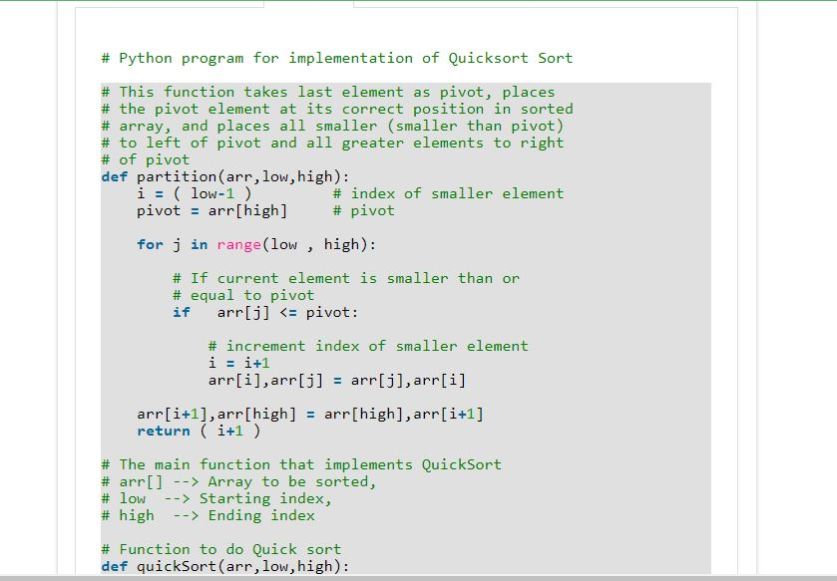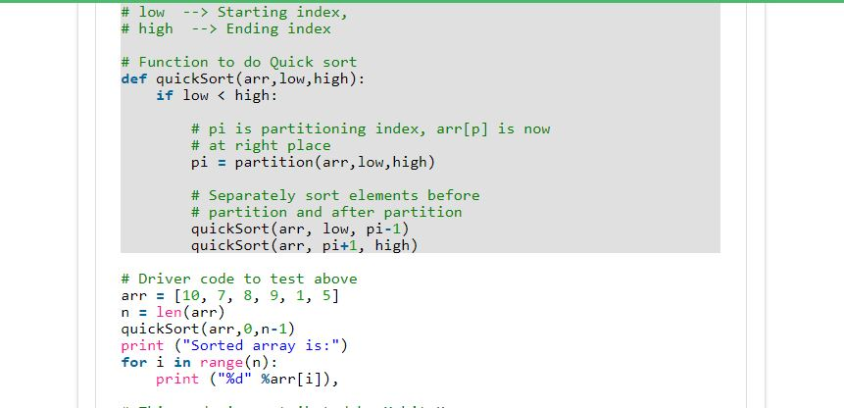 Output:

Sorted array:

1 5 7 8 9 10

**Reference Link:** [**https://www.geeksforgeeks.org/quick-sort/**](https://www.geeksforgeeks.org/quick-sort/)

**Why Quick Sort is preferred over MergeSort for sorting Arrays**  
Quick Sort in its general form is an in-place sort (i.e. it doesn’t require any extra storage) whereas merge sort requires O(N) extra storage, N denoting the array size which may be quite expensive. Allocating and de-allocating the extra space used for merge sort increases the running time of the algorithm. Comparing average complexity we find that both type of sorts have O(NlogN) average complexity but the constants differ. For arrays, merge sort loses due to the use of extra O(N) storage space.

Most practical implementations of Quick Sort use randomized version. The randomized version has expected time complexity of O(nLogn). The worst case is possible in randomized version also, but worst case doesn’t occur for a particular pattern (like sorted array) and randomized Quick Sort works well in practice.

Quick Sort is also a cache friendly sorting algorithm as it has good locality of reference when used for arrays.

Quick Sort is also tail recursive, therefore tail call optimizations is done.

**Merge Sort:**

Like [QuickSort](https://www.geeksforgeeks.org/quick-sort/), Merge Sort is a [Divide and Conquer](https://www.geeksforgeeks.org/divide-and-conquer-introduction/) algorithm. It divides input array in two halves, calls itself for the two halves and then merges the two sorted halves. **The merge() function** is used for merging two halves. The merge(arr, l, m, r) is key process that assumes that arr[l..m] and arr[m+1..r] are sorted and merges the two sorted sub-arrays into one. See following C implementation for details.

**MergeSort(arr[], l, r)**

If r > l

**1.** Find the middle point to divide the array into two halves:

middle m = (l+r)/2

**2.** Call mergeSort for first half:

Call mergeSort(arr, l, m)

**3.** Call mergeSort for second half:

Call mergeSort(arr, m+1, r)

**4.** Merge the two halves sorted in step 2 and 3:

Call merge(arr, l, m, r)

The following diagram from [wikipedia](http://en.wikipedia.org/wiki/File:Merge_sort_algorithm_diagram.svg" \t "_blank) shows the complete merge sort process for an example array {38, 27, 43, 3, 9, 82, 10}. If we take a closer look at the diagram, we can see that the array is recursively divided in two halves till the size becomes 1. Once the size becomes 1, the merge processes comes into action and starts merging arrays back till the complete array is merged.

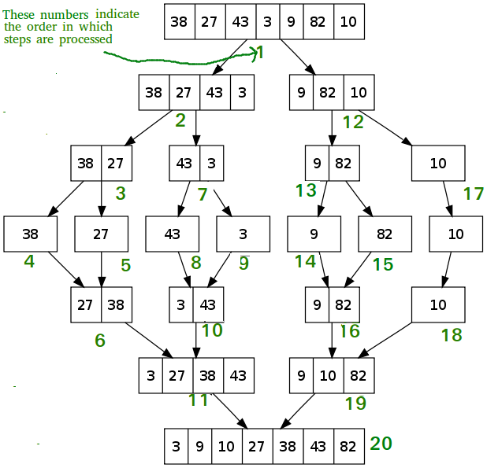

**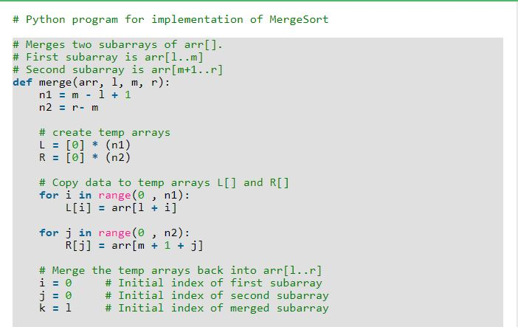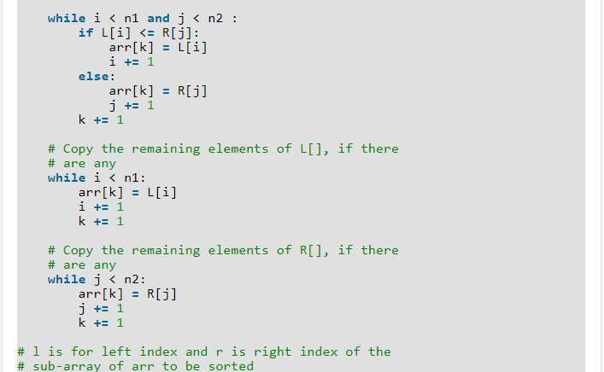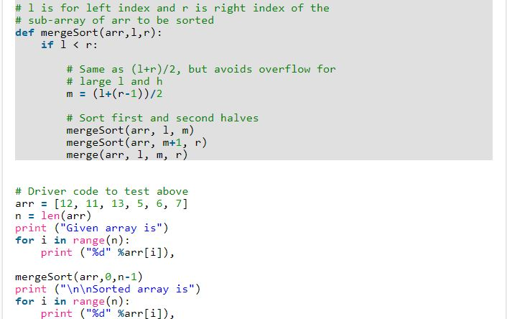**

**Why MergeSort is preferred over QuickSort for Linked Lists?**  
In case of linked lists the case is different mainly due to difference in memory allocation of arrays and linked lists. Unlike arrays, linked list nodes may not be adjacent in memory. Unlike array, in linked list, we can insert items in the middle in O(1) extra space and O(1) time. Therefore merge operation of merge sort can be implemented without extra space for linked lists.

In arrays, we can do random access as elements are continuous in memory. Let us say we have an integer (4-byte) array A and let the address of A[0] be x then to access A[i], we can directly access the memory at (x + i\*4). Unlike arrays, we can not do random access in linked list. Quick Sort requires a lot of this kind of access. In linked list to access i’th index, we have to travel each and every node from the head to i’th node as we don’t have continuous block of memory. Therefore, the overhead increases for quick sort. Merge sort accesses data sequentially and the need of random access is low.